Bynars Media Player

https://github.com/mikebean233/CSCD350_TeamProject

Branches and Merging:

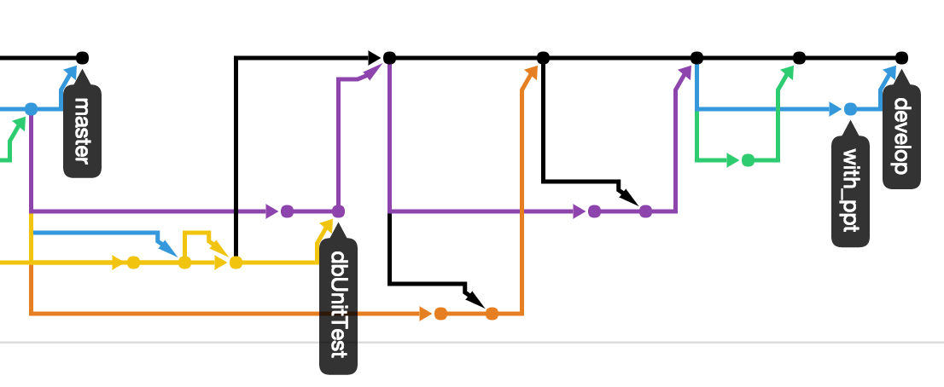

Pull Requests:

